Case 6-Afr-Burkina Faso-Toussian People-Loniake Mask-early 20th c

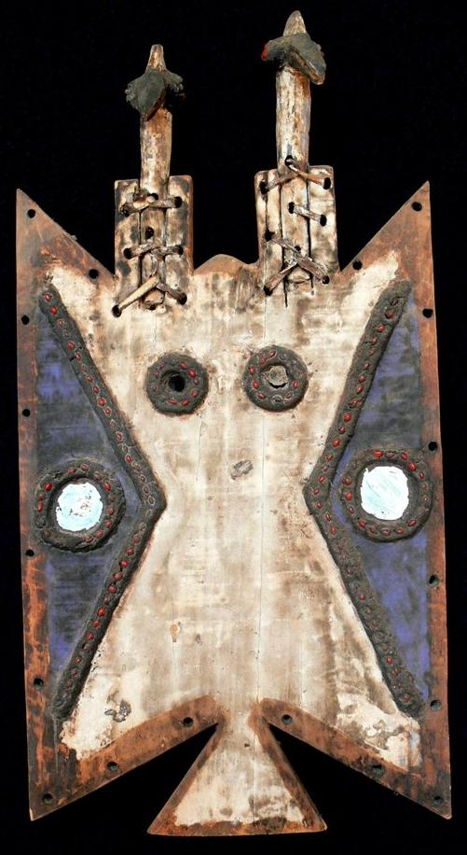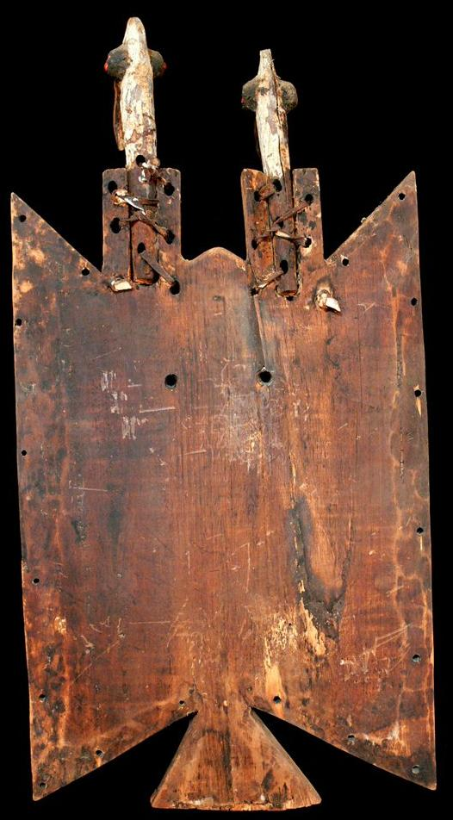

Figs. 1-2. Burkina Faso-Toussian People-Loniake Mask-early 20th c

Formal Label: Burkina Faso-Toussian People-Loniake Mask-early 20th c

Accession Number:

LC Classification: DT553.U75

Date or Time Horizon: Early 20th c

Geographical Area: Burkina Faso, BoBo Dioulasso

Cultural Affiliation: Toussian People

Medium: wood, kaolin paint, charcoal, mirrors, small red seeds

Dimensions: H 29.9 in; W 15.4 in  
Weight: 6.31 pounds

Provenance: Old Dutch Collection

**Condition:** This is an earlt 20th c example of a Loniake mask that has been tribally used.

**Discussion:**

The Toussian (Tusyan) live in the extreme south-western Burkina Faso, have a relatively small, non homogeneous population of about 22,000 according to data collected by C. Roy in his 1987 book *Art of the Upper Volta Rivers*. They share much of their cultural life with their neighbors the Senufo, the Turka and Bobo and speak a very similar language.

This Loniake mask is from the region BoBo Dioulasso in Burkina Faso. Toussian masks are called Loniake and are simple planks that have been joined to make a flat surface that is carved in shallow relief on the front of the mask to define the area that is painted and through which holes in the middle are carved to allow the wearer to see through. A row of holes along the all edges are drilled to attach a fringe made of raffia (grasses). In fact, when the masks are danced the dancer is nude and his only cover are the grasses that cover his lower body.

Loniake masks are carved by blacksmiths in secrecy and women and children are forbidden from seeing their manufacture, the reason being is that the charcoal used is taken from the smithy’s forge where he has manufactured circumcision implements. Metal smithing is considered a secret art because it makes use of fire, and blacksmiths teach their secrets of manufacturing only to chosen initiates. Toussian mask ceremonies regulate the life of the community such as blessing the grain prior to sowing, circumcision of young boys as well as instruction in duties as adults in the village and in their religious training. Masks are also employed in the funeral ceremonies of elders which last three days, after which the deceased's family is designated to keep it for a year. Each male initiate will keep his own mask after he has been initiated and each mask is given a secret name. They were quite often used as divination objects and are and called upon to predict events and ask for guidance by villagers.

The mask would have a bird’s beak (or, in this mask two carved bird’s heads and beaks) attached to the top. The surface is decorated with a base coat of kaolin and other pigments, mirrors and small red seeds set into beeswax in geometrical patterns.

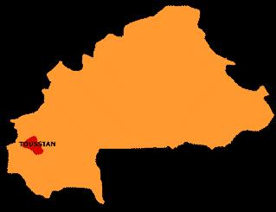

**References:**

[Manega Museum](http://translate.googleusercontent.com/translate_c?depth=1&hl=en&prev=/search%3Fq%3DToussian%26hl%3Den%26lr%3D%26safe%3Doff%26as_qdr%3Dall%26biw%3D1920%26bih%3D1044%26prmd%3Dimvns&rurl=translate.google.ca&sl=fr&u=http://www.musee-manega.bf/&usg=ALkJrhjEtmkMSN7QE_zQX_THOqvGRc8wdQ) 01 PO Box 4904 Ouagadougou, Burkina Faso

Roy, Chistopher D., Chaffin, Françoise. 1987. *Art of the Upper Volta Rivers.* Meudon, France: A. et F. Chaffin.

